Northumberland Coast  Area of Outstanding Natural Beauty  Grant Schemes  Expression of Interest Form | 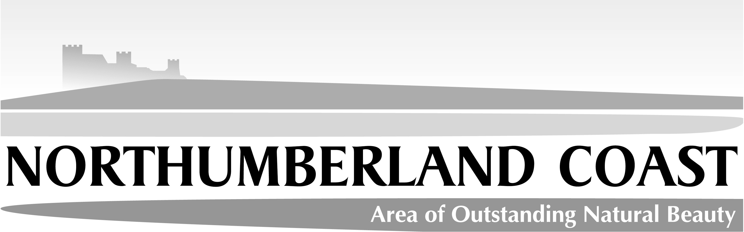

This simple form should be completed for any project that may need to seek funding from one of the two Northumberland Coast AONB Partnership grant funds (the Small Grant Scheme and the Sustainable Development Fund). Please note that the two funds have slightly different criteria; in particular, the SDF requires projects to be innovative, with a clear link to principles of sustainable development.

The completed form should be returned to the AONB Grants Administrator (see over). Initial discussion will then be needed with an appointed member of the AONB staff team to determine the suitability of the project, which scheme is most appropriate, linkages with other initiatives and alternative and/or further funding opportunities, etc.

THIS FORM IS NOT A FULL APPLICATION TO AN AONB GRANT SCHEME
AND WILL NOT BE TREATED AS SUCH

Date August 27th 2009

Name of organisation
Craster Local History Group (CLHG)

Contact name Peter Howard
Address Harbour Lights, Whin Hill, Craster, NE66 3TP

Tel. No 01665 576062 Email Address info@harbourlights-craster.co.uk

Project overview (brief description of the idea, ideally including who it will benefit)
The project seeks to involve members of Craster’s community in:

    - Researching aspects of Craster’s history.
    - Recording that history electronically.
    - Securing the evidence of Craster’s history by making electronic copies of photographs and documents.
    - Increasing wider awareness of Craster’s heritage by
      - Mounting a series of public illustrated talks
      - Publication of evidence and writing on the Group’s pages on the Craster Community Development Trust’s website (www.crastervillage.org.uk)
      - Creation of local history walks in the form of leaflets to be sold to visitors, e.g. from the Craster TIC, with a view to them leaving their cars to explore the area on foot.

The project will benefit:

- The active participants who will develop new skills and find constructive outlets for their creativity and commitment.
- The wider local community who will be able to contribute to the research and become more aware of their heritage.
- Visitors who will have enhanced opportunities to learn about the area.

Project location The civil parish of Craster

Overall project costs £1,500
Potential AONB grant contribution £1,200
The IT resources that would be funded by this bid are all required ‘up front’. The spend on these resources would take place immediately and in full, within a short period of the allocation of any grant. The Craster History Group will fund any further on-going costs.

Are there time limits for delivering the project? Yes, for some aspects
If Yes, please specify: Those aspects of the project which relate to items 1, 2, 3 and the first two bullet points of 4 in the Project Overview will continue through the ongoing programme of the History Group. The work on the walk leaflets will begin immediately but not be concluded until September 2010. The ongoing value of the IT resources being purchased is central to the rationale for buying them and is inevitably not restricted to the current financial year.
Are there any project partners YES
If Yes, please specify (and state: (a) if they have been approached yet and, (b) whether they are potential funding partners)

The Craster Community Development Trust is supportive in principle and has provisionally offered a contribution of £200 to initial project costs.

The CLHG will contribute £100 to initial costs and meet the ongoing further costs which will arise over time. We are asking for support to purchase the necessary IT equipment, members of the CLHG will contribute substantially through their time commitment to the project.

Continued over leaf….

Any other information
The initial cost of the project, estimated at £1,500, is to purchase a laptop, digital projector and software. Ongoing costs, not included in the grant application would involve such items as maintenance of IT, publication costs and rental of the Craster Village Hall (the venue for public talks). All of the ‘labour’ will be voluntarily provided by the community.

* Progression to full application stage does not guarantee funding *

For office use only
Relevant officer’s comments

Recommended action
Not applicable to either scheme, supplied with alternative grant source information* □
Pursue to full application to SDF □
Pursue to full application to SGS □
Elected support officer

Further contacts, partner organisations etc:

*Other grants source information provided:

Please return to: Catherine Gray, by email or post:
Email: CGray@Northumberland.gov.uk
POST: Northumberland Coast AONB Partnership, County Hall, Morpeth, Northumberland, NE61 2EF

